

Name :Muhammad Shaheer
Roll no:20p-0480
Subject :Operating Systems Lab
Lab TASK: 4

Below is the attached two Applications one is a Node app and one
is a Python app, run both applications using docker-compose and take
screenshot of the running containers and the browser output attach in
PDF and submit.
1. In the Node app, create a user with your name and
email and take screenshot, take screenshot from the
Database(mongo-express) after this update the user from UI and changes
should be reflected in Database.
2. In the Python app, refresh 15 times and take a screenshot.

Solution:
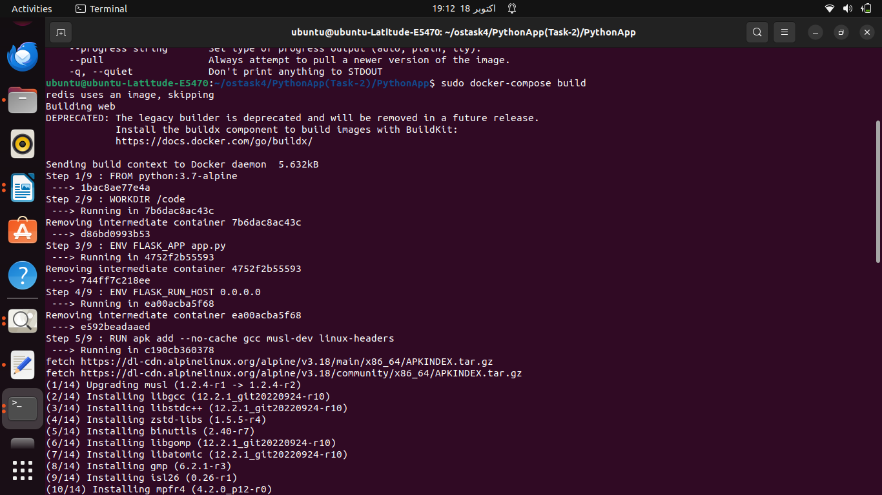
1:Extract all files in one folder and first open Python app folder and in terminal run this commands:
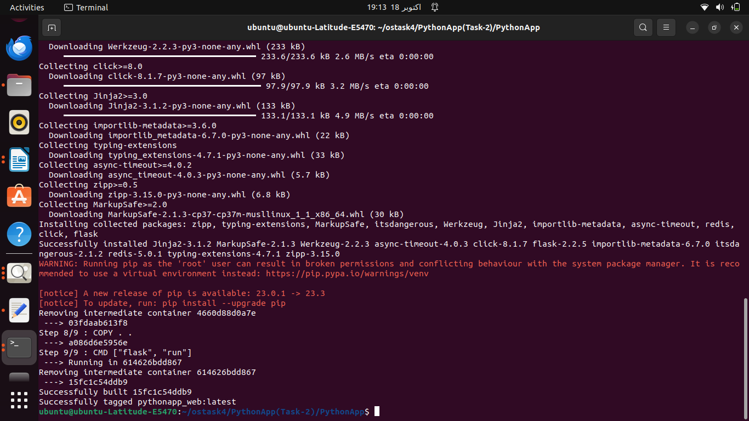
2:Now open node app and run this commands:

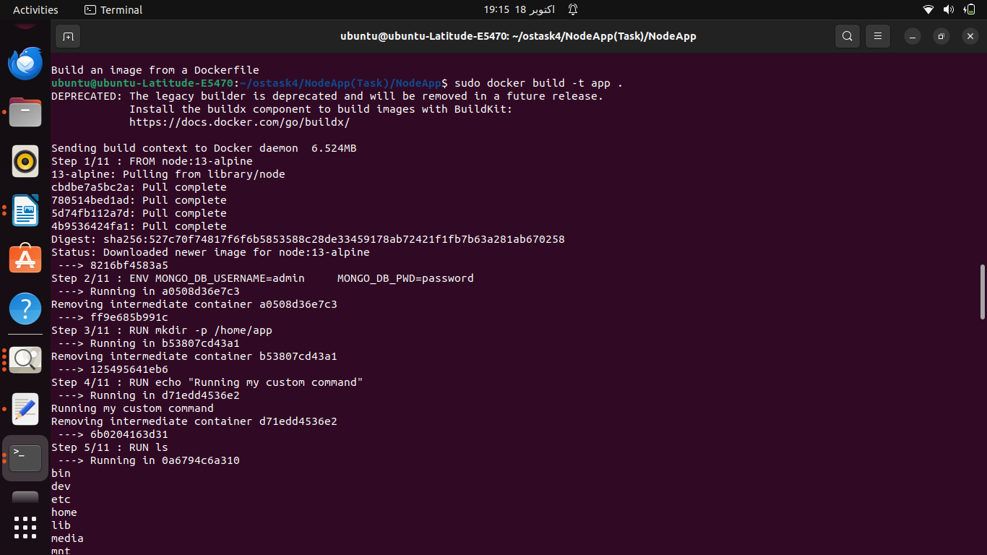
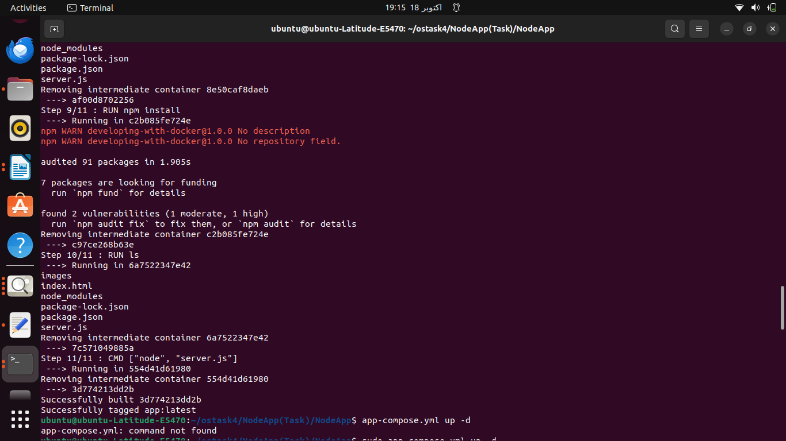
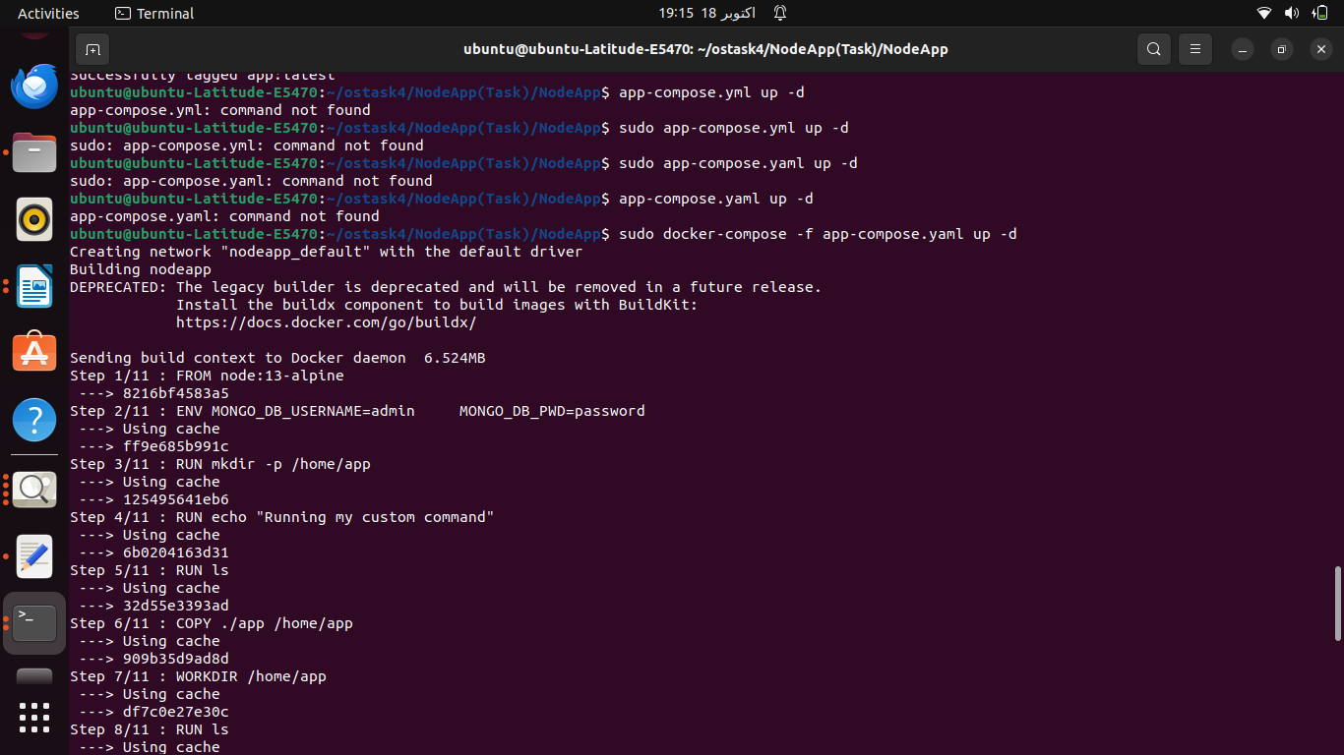

Now check for containers execution:

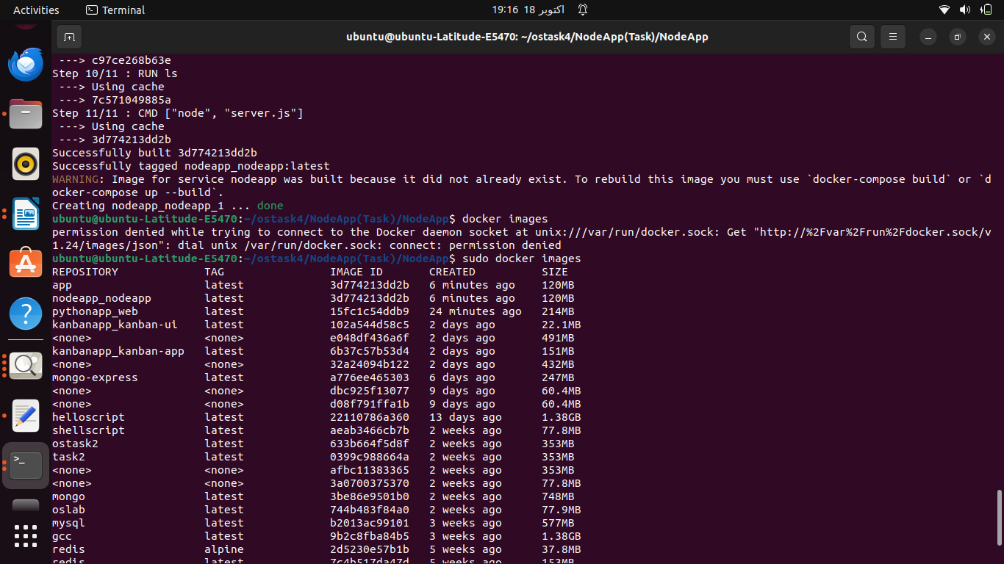

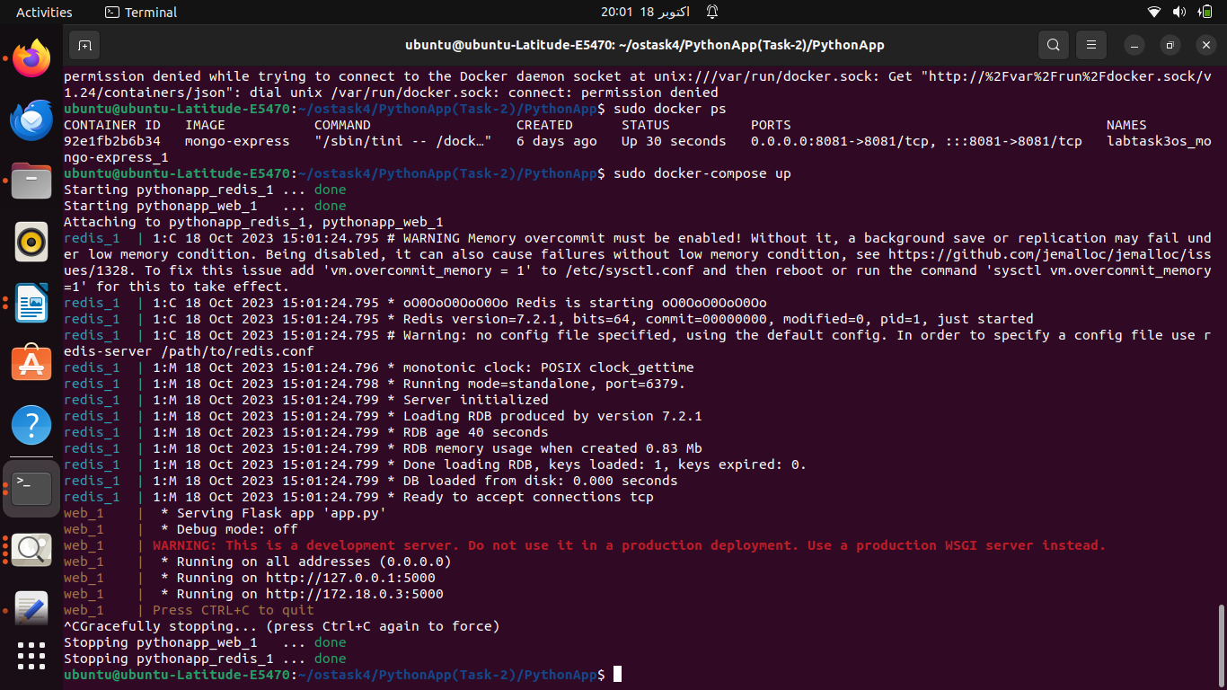

Encountered Errors:

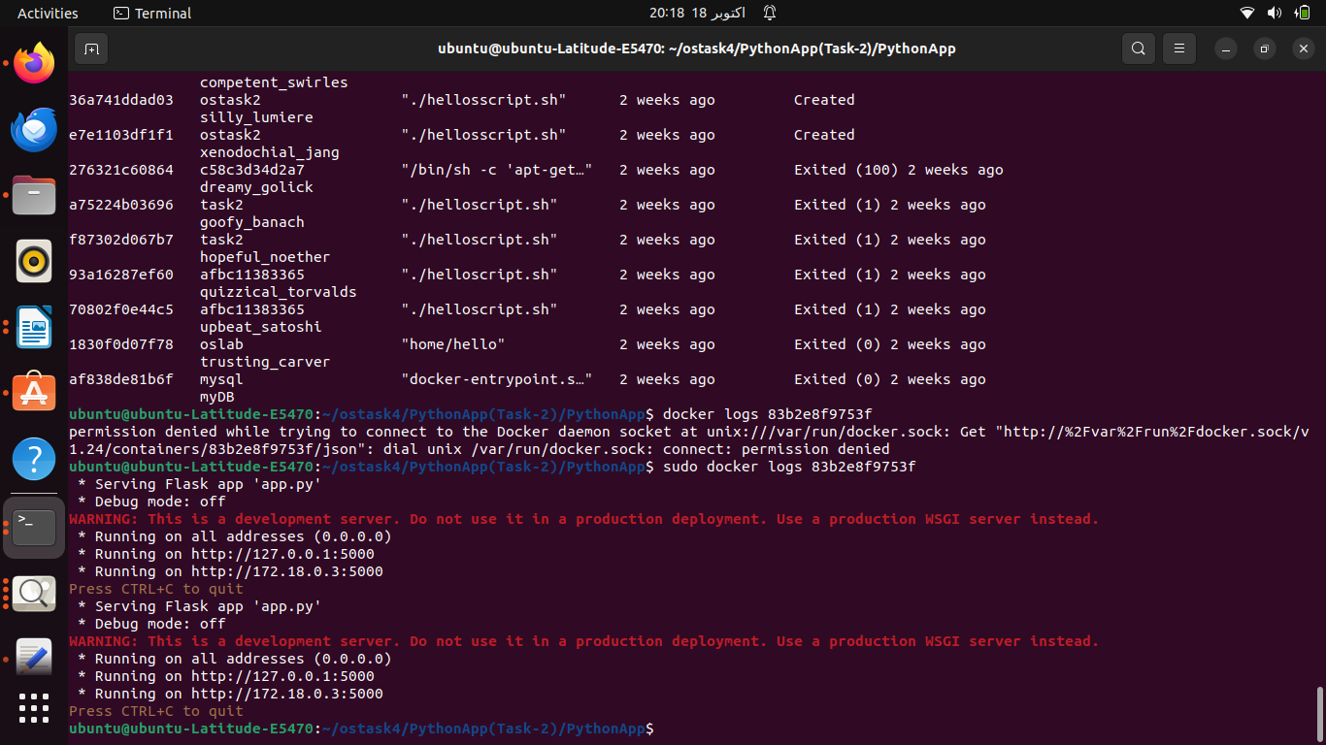
After building container again its run

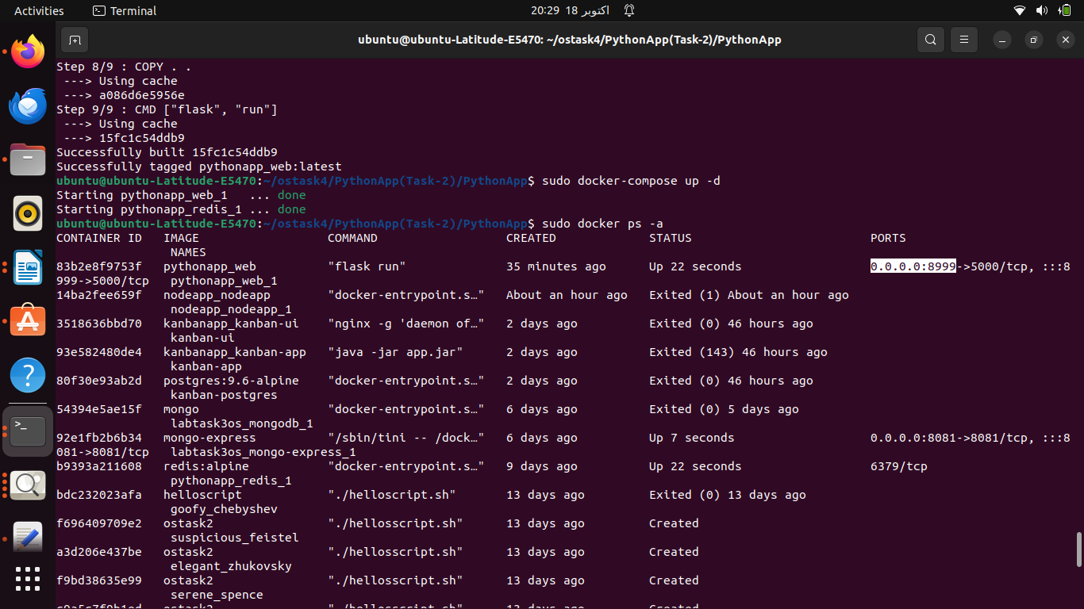

Output:

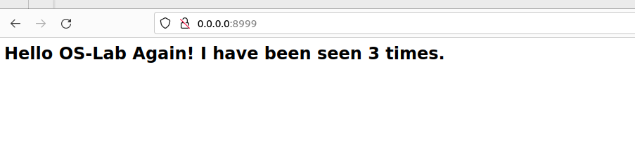
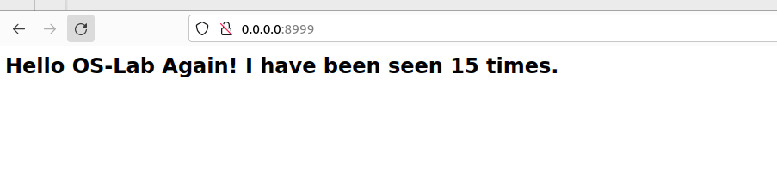

Task 2 done .

After building nodeapp container using build and up commands

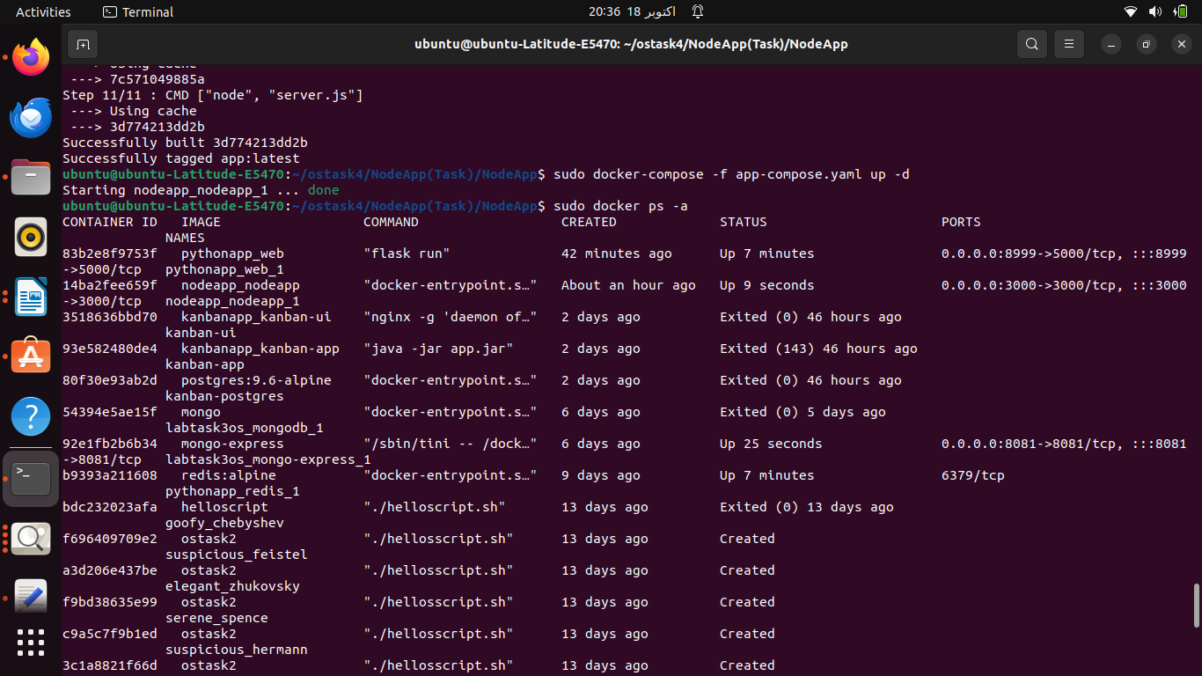

When open link:

